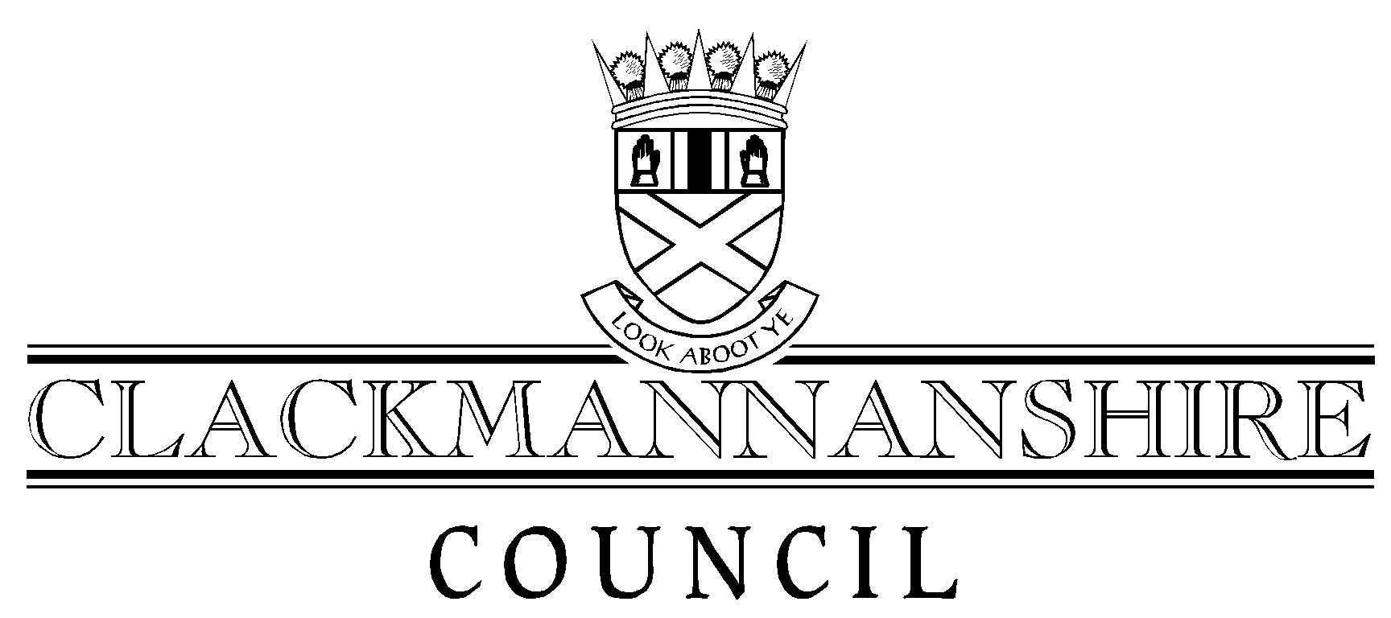
Report to Performance and Audit Committee
To accompany all Reports to Performance and Audit Committee

To: Head of Administration And Legal Services
Author: | Stuart Crickmar, Business Improvement Manager | Date: | 13 March 2007
Service: | Business Improvement & Technology Services
Date of Meeting: | 22 March 2007
Title of Report: | A Proportionate & Integrated Approach to Best Value

Recommendation that the attached report be:
1. Given unrestricted circulation | ✓ | (tick appropriate box)
2. Taken in private
By virtue of paragraph ____ of schedule 7A, Local Government (Scotland) Act 1973.

Appendices attached to this report (if none, state “none”)
1. | None
2.
3.
4.

List of Background Papers (if none, state “none”)
1. | Sustainability checklist
2. | A Proposal for the Future of Best Value Reviews: Report to Council of 31 March 2004 - Dave Jones, Director of Services to People
3.
4.
Note: All documents specified must be kept available by the author for public inspection for four years from the date of the meeting at which the report is considered.

