CLACKMANNANSHIRE COUNCIL

Report to Regulatory Committee of 16th October, 2008

Subject: Extension to Rear of House and Erection of Garage at 20 East Stirling Street, Alva, FK12 5HA (08/00266/FULL).

Applicant: Joe McNulty, 13 Rhodders Grove, Alloa, FK12 5ER
Agent: A. Peebles, Architectural Drawing Services, 6 Tulliallan Terrace, Kincardine, FK10 4QA.

Prepared by: Mark Stoddart, Planner.

Ward: Clackmannanshire North.
- SUMMARY
  - The application is for a storey and a half extension and a double garage to the rear of the house. The extension will continue the existing roofline and use the same finishes as the existing house. The garage will be accessed by a new access onto The Glebe with the formation of an entrance in the boundary wall. It will be finished to match the existing house.
  - Subject to conditions requiring amendments, the proposals maintain standards of residential amenity and design and comply with relevant development plan policy guidance. The application has attracted five letters of objection which have been carefully considered. The applicant has been contacted and has amended their plans to remove a proposed door in the east elevation and reduce the width of the extension by 0.5 m. Due to this and not withstanding the objections received from neighbours there are no grounds for withholding planning permission for either element of the proposed development.
- RECOMMENDATION
  - That the application be approved subject to the following conditions.
1. The position of the garage shown on the block plan is hereby NOT approved. Prior to the start of work on the garage, a revised plan showing the garage positioned a minimum of 5.5 m from the rear boundary shall be submitted for the approval of the Council. Once approved, the garage shall be constructed in accordance with the approved plan.
2. The ground floor window shown on the east elevation of the extension is hereby NOT approved. Prior to the start of works, an amended plan showing the window removed, shall be submitted for the approval of the Council. Once approved, the extension shall be constructed in accordance with the approved plan.
3. The garage hereby approved, shall be used for domestic purposes only, ancillary to the use and enjoyment of the house, and for no business or other purpose.
4. Before the access is brought into use, 2 m sections of the boundary wall either side of the access shall be lowered to a height not exceeding 1 m above carriageway level.
Reason
1. In the interests of road safety.
2. In the interests of neighbour privacy.
3. In the interests of residential amenity.
4. In the interests of road safety.
- BACKGROUND
  - The property comprises a semi detached, single storey house to the front of the property. The property has a frontage to both East Stirling Street and The Glebe. To the rear of the property is a 26 m long garden with a high wall on the rear boundary. There is an existing pedestrian gate within the rear wall. On both side boundaries there are 1.8 m high hedges. The hedge on the eastern boundary drops to 1.2 m at the edge of the house and continues at this height to the front boundary.
  - The application is for a rear one and a half storey extension and double garage. The extension would be 5.3 m deep and 7.3 m wide. The ground floor would be 4.3 m by 6.5 m. At first floor level there would be a balcony to the rear supported by brick pillars. This would be contained below the new roof structure. A dormer would be constructed on the west elevation. A window is shown on the ground floor of the extension with a roof light at first floor level.
  - The proposed garage would measure 5.9 m by 5.5 m with a peaked roof of 5.1 m, being some 5 m from the rear boundary and 1.2 m from the western boundary.
- CONSULTATIONS
  - Roads and Transportation - have no objections to the creation of the access but require that it meets their specifications in terms of width, visibility and length of driveway. Comment - A condition has been included to deal with the latter issue. The applicant will have to apply for a Minor Roadworks Consent for the works needed to create the access. There is nothing on the plans that would prevent compliance with the Roads advice, relating to visibility and the width of the access.
- REPRESENTATIONS
  - The application was notified to 12 neighbours. We have received representations from
Angela Watson, 2 Glebe Terrace, Alva
Charles Bryne, 18a East Stirling Street, Alva
Mr A MacDonald, 1 Glebe Crescent, Alva
D Chalmers, 20a East Stirling Street, Alva
Linda and David Simpson, 18 East Stirling Street, Alva
The following concerns were raised.
  - Concerns relating to the loss of view. Comment - the preservation of someone's view from a property is not a material planning matter
  - The new access and garage will adversely affect carparking on the street. Comment - The Roads Service has no objections to the formation of the access. On balance, on street carparking will be improved as a result of the proposal.
5.4 The creation of the new side door will reduce privacy as visitors using this door can look into neighbouring windows. Comment. The applicant has removed the door from the proposal.
5.5 The limited space between the properties (2.1 m) makes access difficult. Comment - The space between the house and the boundary hedge is sufficient for a path but the proposed door has been removed from the application. The proposal has been amended to increase the distance between the extension and the boundary to 1.35 m.
5.6 The extension will reduce the amount of daylight to the living room / kitchen. Comment. The extension uses the same pitch as the existing roof. The wallhead, at only 2.8 m above ground level maintains the height and alignment of the existing house and the amount of daylight to these windows will not be reduced significantly. In any event, the kitchen and living room windows already face the existing side wall rather than the proposed extension. The amended plan shows the extension moved 0.5 m away from the boundary which will further reduce any impact from the extension.
5.7 The extension with the ground floor window and the balcony will reduce privacy in neighbouring properties. Comment - It is accepted that the ground floor window is unacceptable and a condition is included that removes this window. The position, cill height and angle of the first floor rooflight will combine to avoid any loss of privacy. The view from the balcony is restricted as it is set back into the extension. The design of the balcony means that the area on the adjoining property closest to the house will not be in view.
5.8 The development will shade a neighbouring rear garden. Comment - the extension is 5.3 m deep with a pitched roof. It has a low wallhead. Despite the relative proximity to the side boundary, the shading from the extension will not significantly effect the neighbouring property.
5.9 The extension will affect the character / nature of the house. Comment - the extension will not be seen from the front of the house. The use of the same materials for the extension and the continuation of the same roof pitch mean that the character of the house is safeguarded.
5.10 The new access will increase traffic in the street and result in vehicles being parked in the street. Comment - the area shown for the driveway is sufficient to accommodate two vehicles with two more in the garage. The formation of the access itself does not require planning permission.
5.11 The property will be used to store a commercial vehicle. Comment - the lawful use of the property is residential. The garage will have a condition reinforcing this position.
- PLANNING CONSIDERATIONS
  - The proposals have been assessed against the relevant policies in the Local Plan, including the supplementary guidance on house extensions. We have also taken account of the representations from neighbours.
  - The extension increases the footprint of the house by 40 %. The extension continues the same roof line as that existing and retains the style of the house. There will be 22 m between the extension and the rear boundary and 11.4 m between the extension and the proposed garage. This leaves ample open space to the rear of the house. The extended house will occupy 30% of the overall plot which meets the standard include in the Local Plan.
  - The depth of the driveway should be a minimum of 5.5 m rather than the 5 m to ensure that overall space for parking is provided and this will be covered by a condition. The width of the proposed access accords with the advice from the Roads Service. An additional condition is proposed to improve the visibility either side of the access.
  - The proposals have been carefully examined in the context of their relationship to neighbouring properties, the standards of residential amenity which neighbours can reasonably expect to enjoy and the characteristics of the applicant's property. Insofar as many of the representations focus on these issues, our detailed analysis is largely described in Section 5 above. From this, we conclude that the scale of the development, and its design characteristics, are proportionate to the location, and by and large maintain standards of privacy and amenity.
  - In recommending approval, however, we are proposing the deletion of a side window that might potentially have an adverse affect on the privacy of the neighbour to the east. Otherwise, we conclude that the development is policy compliant.
- SUSTAINABILITY IMPLICATIONS
  - None.
- FINANCIAL IMPLICATIONS
  - None
8.2. Declarations
(1) The recommendations contained within this report support or implement Corporate Priorities, Council Policies and/or the Community Plan:
- Corporate Priorities (Key Themes) (Please tick ☑)
Achieving Potential □
Maximising Quality of Life
Securing Prosperity □
Enhancing the Environment ☑
Maintaining an Effective Organisation □
- Council Policies (Please detail)

- Community Plan (Themes) (Please tick ☑)
Community Safety □
Economic Development □
Environment and Sustainability ☑
Health Improvement □
(2) In adopting the recommendations contained in this report, ☑
the Council is acting within its legal powers. (Please tick ☑)
(3) The full financial implications of the recommendations contained ☑
in this report are set out in the report. This includes a reference
to full life cycle costs where appropriate. (Please tick ☑)

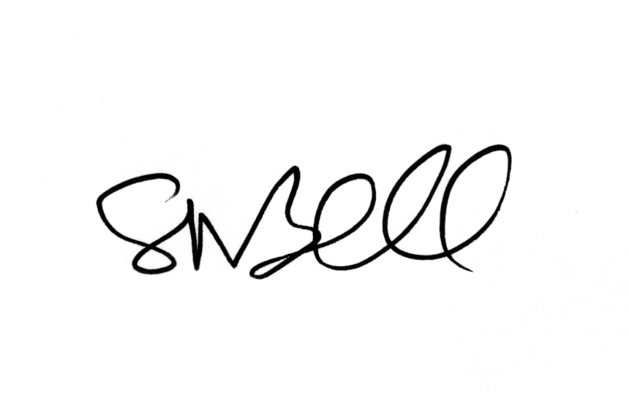
____________________________
Head of Development Services

