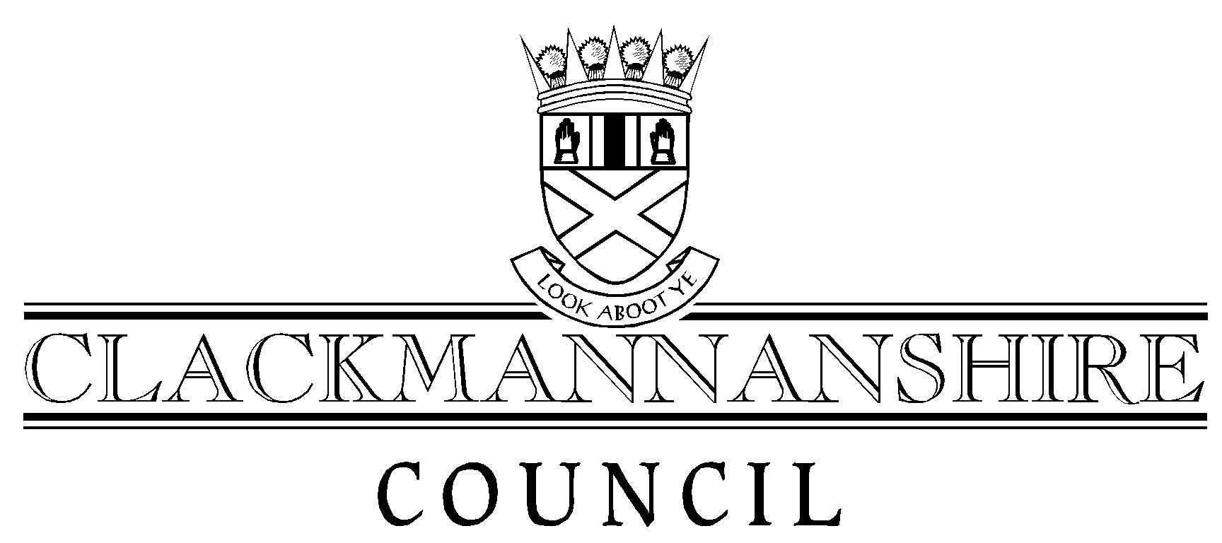
Report to Regulatory Committee
To accompany all Reports to Regulatory Committee

To: Head of Administration And Legal Services
Author: | Keith Johnstone, Principal Planner | Date: | 18 December 2007
Service: | Development Services
Date of Meeting: | 10th January 2008
Title of Report: | Planning Application: Form External Flue And Reconsider Condition 4 Of Planning Permission 06/00172/FULL Restricting Preparation, Cooking And Reheating Of Food By Microwave Ovens At 133 West Stirling Street, Alva (Ref 07/00364/FULL)

Recommendation that the attached report be:
1. Given unrestricted circulation | ✓ | (tick appropriate box)
2. Taken in private
By virtue of paragraph ____ of schedule 7A, Local Government (Scotland) Act 1973.

Appendices attached to this report (if none, state “none”)
1. | None
2.
List of Background Papers (if none, state “none”)
1. | Clackmannanshire Local Plan
2. | Consultation Replies From Environmental Health
3. | Letter of Objection From Alva Community Council
4. | Planning Files 07/00195/FULL, 06/00300/FULL, 06/00172/FULL, 05/00109/FULL and 02/00159/FULL
Note: All documents specified must be kept available by the author for public inspection for four years from the date of the meeting at which the report is considered.

