CLACKMANNANSHIRE COUNCIL

Report to Regulatory Committee of 26 April 2007

Subject: Street Naming – New Alva Academy Access Road

Prepared by: Mark Grant, Administrator, Building Standards
- SUMMARY
  - This report sets out the results of the consultation exercise seeking a suggested name for a street in Alva.
  - Following careful consideration of the suggestions and having regard to the criteria for choosing names, it is recommended that the name identified in paragraph 2.1 be agreed.
- RECOMMENDATIONS
  - It is recommended that the following name is agreed:
Academy Road
- BACKGROUND
  - Research has been carried out and consultation undertaken in order to identify a suitable name for a new street in Alva.
  - The consultation and research process involved contacting the local Councillors, the Community Council, local schools and known heritage groups and interests. A full list of consultees, with their responses, is appended at Appendix 1.
  - The Royal Mail Address Development Centre has also been consulted and the recommended name is considered acceptable. Should an alternative name be chosen, further consultation with Royal Mail would be required.
- PROPOSAL
  - Having considered all of the suggestions very carefully it is considered that the following name would be most suitable:
Academy Road
- SUSTAINABILITY IMPLICATIONS
  - The recommendation does not have any significant sustainability implications. The consultation and research procedure ensures that community participation has been undertaken.
- FINANCIAL IMPLICATIONS
  - None.
6.2. Declarations
(1) The recommendations contained within this report support or implement Corporate Priorities, Council Policies and/or the Community Plan:
- Corporate Priorities (Key Themes) (Please tick ☑)
Achieving Potential □
Maximising Quality of Life □
Securing Prosperity □
Enhancing the Environment ☑
Maintaining an Effective Organisation ☑
- Council Policies (Please detail)
Tri-Council agreed Street Naming and Numbering Conventions
- Community Plan (Themes) (Please tick ☑)
Community Safety □
Economic Development □
Environment and Sustainability □
Health Improvement □
(2) In adopting the recommendations contained in this report, ☑
the Council is acting within its legal powers. (Please tick ☑)
(3) The full financial implications of the recommendations contained □
in this report are set out in the report. This includes a reference
to full life cycle costs where appropriate. (Please tick ☑)

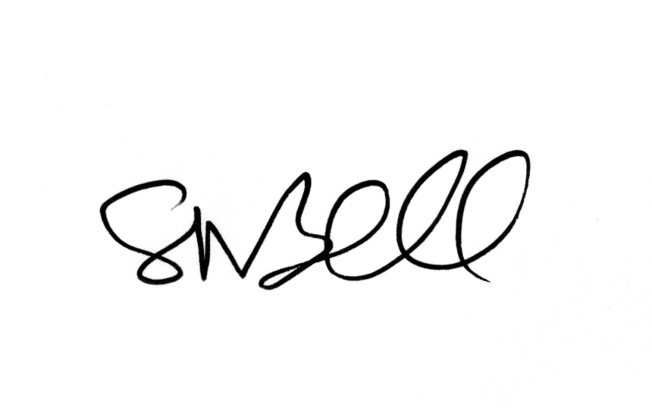
______________
Head of Service

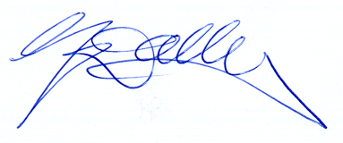
____________________________
Director

APPENDIX 1 – CONSULTEE RETURNS - NEW ALVA ACADEMY ACCESS ROAD

CONSULTEE | SUGGESTION | REASON FOR SUGGESTION
Councillor Balsillie | Scholars | (by phone and to reflect the purpose of the road and (for Enterprise) geographical connection
Councillor Balsillie | Academy
Councillor Balsillie | Enterprise
Alva Community Council | Did not respond to consultation
Alva Academy | 1. Academy | As a result of a poll conducted with pupils and staff the aforementioned are the favoured suggestions of the school in order of the first to fifth
Alva Academy | 2. Quality
Alva Academy | 3. Hillfoots
Alva Academy | 4. Glenview
Alva Academy | 5. School
Alva Primary School | Did not respond to consultation
Clackmannanshire Field Studies Society | Did not respond to consultation
Museum & Heritage Officer | Did not respond to consultation
Reference Librarian | Silverburn Road | After the burn in the vicinity
Reference Librarian | West Silverburn | After the burn in the vicinity

