CLACKMANNANSHIRE COUNCIL

Report to Regulatory Committee of 1st February, 2007

Subject: Street Naming

Prepared by: Susan Munro, Administrator, Building Standards

Ward: St. Serf’s – Councillor Carrick
- SUMMARY
  - In accordance with the Council’s approved procedure and taking cognisance of all responses from the responding consultees, it is recommended the street name noted in paragraph 2.1 is approved by the Committee.
- RECOMMENDATION

  - POSTAL ADDRESSES – OCHIL VIEW HOUSING ASSOCIATION LTD,
NEWMILLS, TULLIBODY:

Paterson Place
- BACKGROUND
  - This report recommends a new street name for a site at Newmills, Tullibody. A list of suggestions received is appended to this report. Consultation has also been undertaken with the Royal Mail Address Development Centre and the Royal Mail shall issue a postal code for the development in due course. It should be noted that the recommended street name is considered acceptable by the Royal Mail. Should an alternative street name be chosen, the Royal Mail would have to be re-consulted.
- CONSULTATION AND RESEARCH
  - The consultation and research process involves the Service contacting parties within the local community e.g. relevant Councillor(s), Community Council, local heritage groups etc.
The results of this process are then compiled (see appendix 1), reviewed and the most appropriate selected and recommended for approval.
- CONCLUSIONS
  - The recommendation for the new name at Newmills, Tullibody in paragraph 2
of “Paterson Place” is based on a suggestion made by Ian Murray, Information Librarian and Archivist and would honour the work/role of William Burns Paterson, who was born in Tullibody in 1850. (please see appendix 1).
- SUSTAINABILITY IMPLICATIONS
  - The recommendation does not have any significant sustainability implications. The consultation and research procedure ensures that community participation has been undertaken.
  - Declarations

1. The recommendations contained within this report support or implement Corporate Priorities, Council policies and/or the Community Plan: | Reference
Corporate Priorities
Council Policies
Community Plan
2. In adopting the recommendations contained in this report the Council is acting within its legal powers. | ☑
3. The full financial implications of the recommendations contained in this report are set out in the report. This includes a reference to full life cycle costs where appropriate. | □
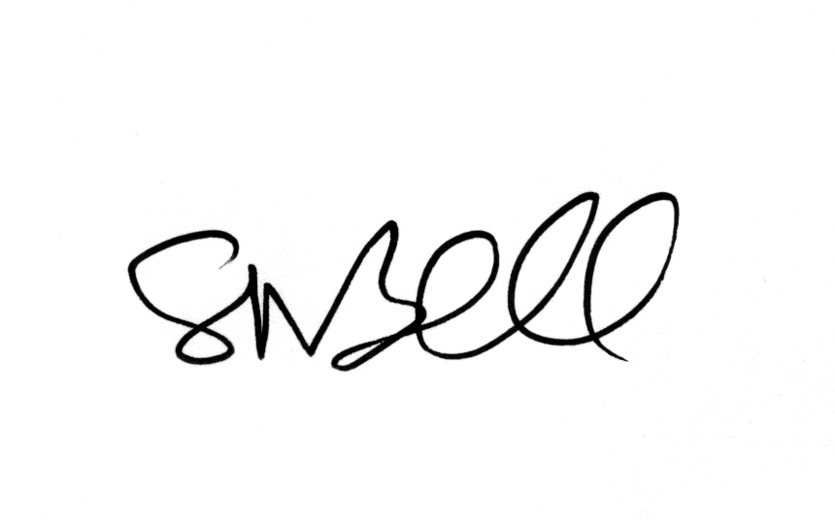
Head of Development Services
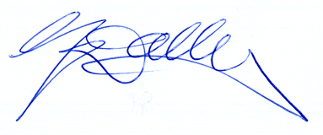
Director of Development & Environmental Services

