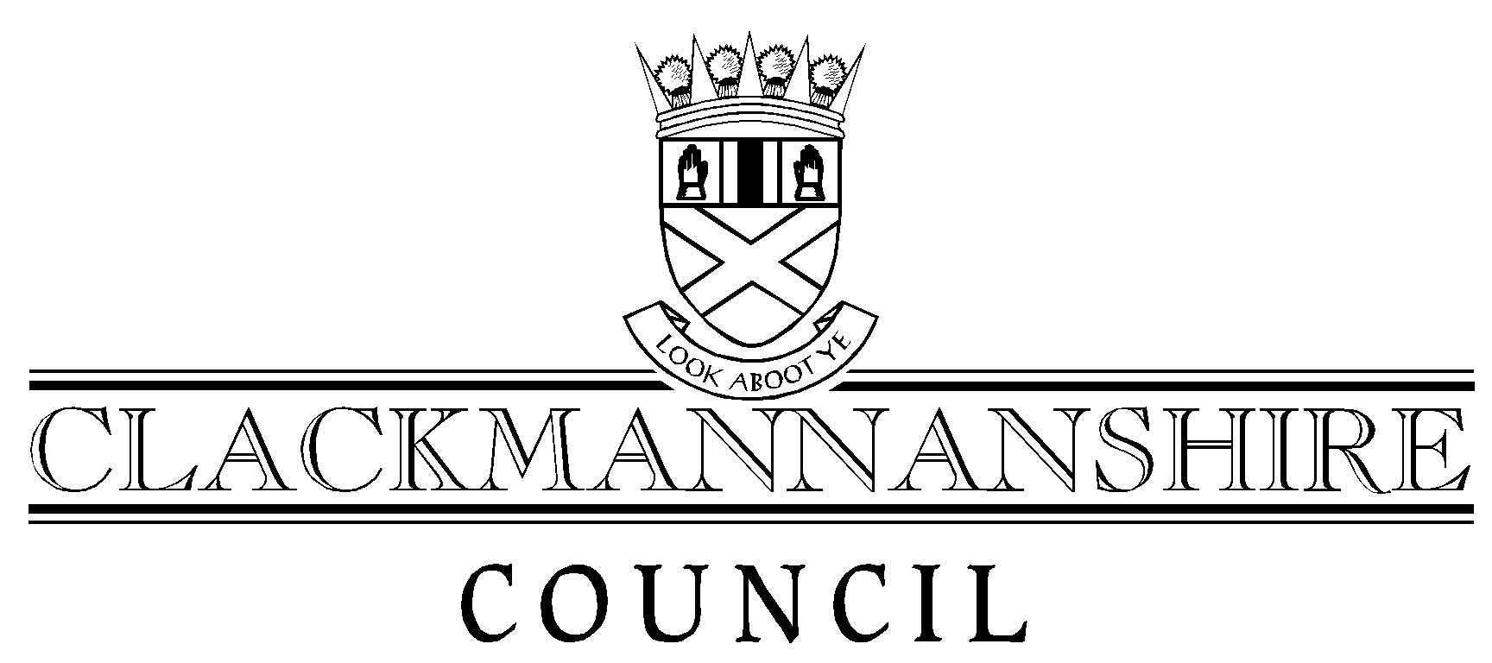
Report to Council
To accompany all Reports to Council

To: Head of Administration And Legal Services
Author: | Juliet Hamilton and Mac West | Date: | 15 February 2008
Service: | Development & Environmental Services
Date of Meeting: | 13th March 2008
Title of Report: | Potential Acquisition of Gartmorn Dam

Recommendation that the attached report be:
1. Given unrestricted circulation | ✓ | (tick appropriate box)
2. Taken in private
By virtue of paragraph ____ of schedule 7A, Local Government (Scotland) Act 1973.

Appendices attached to this report (if none, state “none”)
1. | Plan
2.
3.
4.

List of Background Papers (if none, state “none”)
1. | Countryside (Scotland) Act 1967
2. | Reservoirs Act 1975
3. | Land Reform (Scotland) Act 2003
4. | Nature Conservation Act 2004
5. | JBA Consulting Report October 2007
Note: All documents specified must be kept available by the author for public inspection for four years from the date of the meeting at which the report is considered.

