Appendix 1

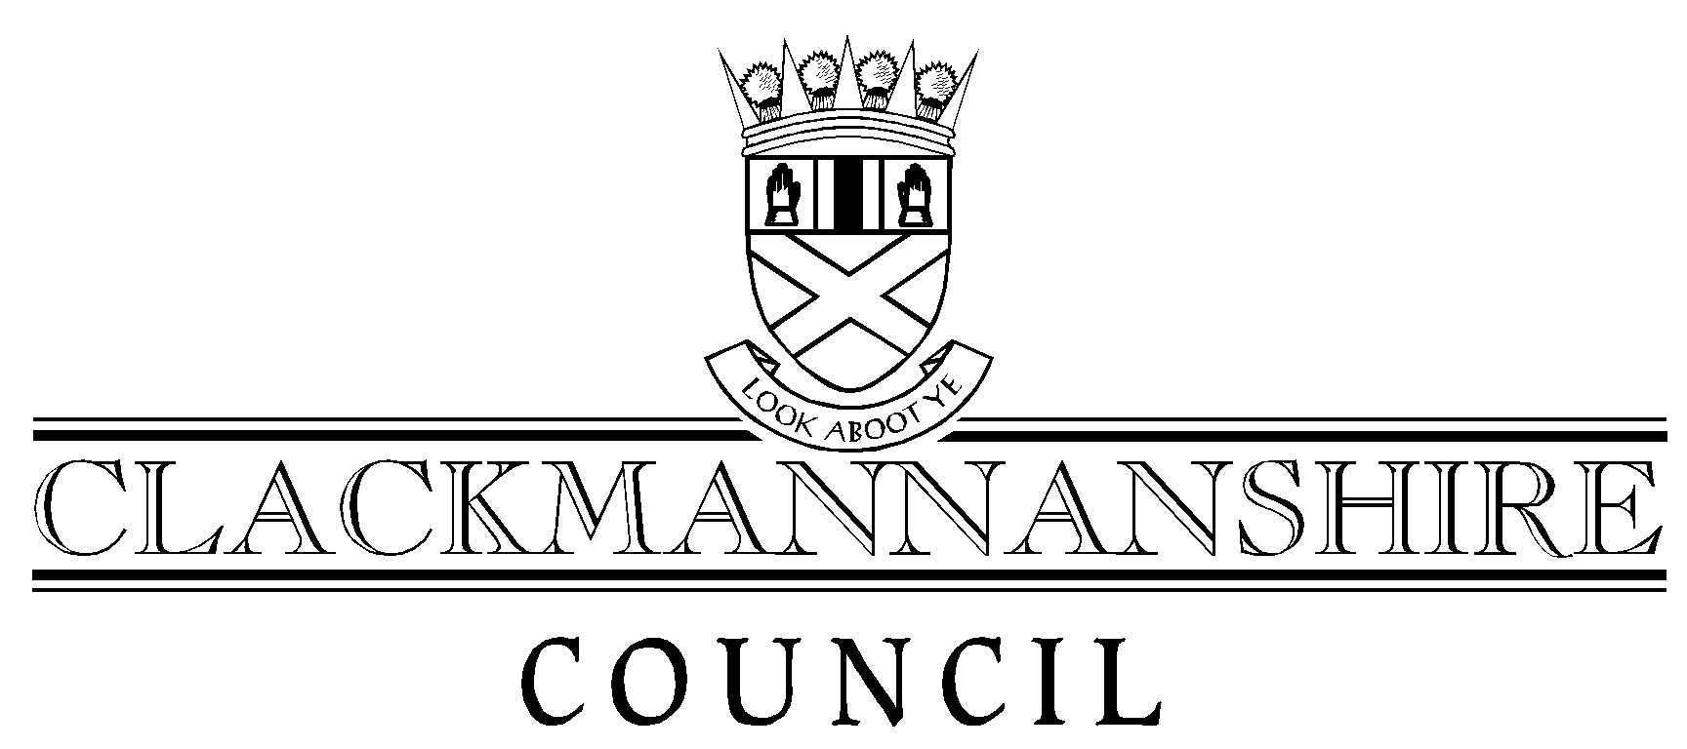

Corporate Debt Policy

Contents

Section Page
1.0 Aims and objectives 3
2.0 Provisions of the Policy 3
2.1 Billing 3
2.2 Collection 3
2.3 Recovery 4
2.4 General provisions 5
3.0 Effectiveness 5
4.0 Benefits 5
5.0 Implementation Specifics and Monitoring 6
6.0 Bad Debt 7

- Aims and objectives of the policy.

1.1 To set out policy in relation to the billing ,collection and recovery of all types of debt due to the Council including the promotion of effective debt collection and the prevention of bad debt.

  - To make clear how the Council will engage with debtors.

  - To make clear the action that the Council will take where debt is not paid on time.

- Provisions of the Policy

2.1 Billing

The Council considers that all taxpayers, ratepayers and other debtors have a responsibility to pay all amounts properly due on time and to that end the Council will:

- Ensure that all bills etc are clear, accurate and issued promptly.
- Ensure that all bills promote the availability of benefit, reduction and relief.
- Develop the use of electronic billing for all appropriate type of debt.
- Ensure information on Clacksweb on all types of debt is clear, informative and kept fully up to date.
- Ensure that all bills promote the most convenient and cost effective payment methods.
- Regularly review the style and content of bills, demands, arrears notices etc to ensure their continued effectiveness.
- Respond quickly to any information that will change amounts due and re-bill promptly and accurately.
- Respond quickly to any enquiry from a debtor about what they are being asked to pay.
- Provide translation services or help with interpretation.
- Ensure charge and payment information on internal debtors accounts is maintained accurately and up to date.
- Where appropriate have procedures in place to encourage payment in advance of service provision.
- Encourage all debtors to tell the Council as soon as they realise they may have a problem in paying on time.
- Share billing and other debtor information between services to ensure consistency of data across the organisation.

2.2 Collection

In order to maximise collection levels throughout the community and make it easy and convenient for debtors to pay the council will:

- In addition to any statutory payment instalment plans provide alternative plans on request to suit individual debtor needs.
- Provide a wide variety of cost effective and accessible payment facilities.
- Actively promote the use of automated and electronic payment methods including Direct Debit, Internet payments and payment by phone.
- Actively encourage all Clackmannanshire Council employees who live in the area to pay Council Tax and/or Rent by deduction from wages/salary.
- Provide effective payment media such as payment cards and payment slips.
- Provide informative receipts for payments received.
- Ensure that all collection staff have access to accurate and up to date billing and account information.
- Develop online access for citizens to access their accounts.

2.3 Recovery

The Council will deal with the recovery of debt in a fair, equal and objective way in order to maximise recovery for the community whilst being sympathetic to the needs and circumstances individual debtors.

In this regard the Council will:

- Encourage all debtors to pay promptly and regularly and thereby discourage non-payment.
- Encourage all debtors to tell the Council as soon as they realise they may have a problem in paying on time.
- Have regard to the ability to pay irrespective of the type of debt.
- Where multiple debt is identified attempt to strike a fair balance between the claims of competing creditors. This recognises that people need to be able to maintain an acceptable standard of living whilst paying off debt.
- Ensure that services work closely together and share relevant information with a view to maximising collection levels.
- Where appropriate provide information, advice and assistance to debtors on available reductions and benefits helping to maximise income and reduce the debt.
- Promote the availability of specialist independent money advice and welfare benefits advice provided by the Council and also by the CAB and other voluntary organisations.
- Treat all debtors as individuals and consider wherever possible personal and financial circumstances when taking action for recovery.
- Attempts to reach mutually acceptable payment arrangements at all stages of recovery recognising that where this is cannot be achieved recovery action will be progressed using all available and appropriate legal powers.

2.4 General provision

The Council recognises that maximising collection levels is important for the whole community and to that end:

- Will apply the terms of this policy irrespective of the nature of the debt .
- Ensure that all written communication about debt is in ‘Plain English’ and encourages contact either in person or by phone at the earliest possible stage.
- Will provide clear information about how and where to get independent financial advice.
- Will provide clear information on all aspects of the collection and recovery processes including where to get help and advice on the effect.
- Set out annual targeted recovery plans and make every effort to adhere to these.
- Comply with all statutory requirements in relation to Billing, Collection and Recovery.
- Comply with the Office of Fair Trading guidelines on debt collection.
- Ensure our Debt Collection Agents and Sheriff Officers conform to a Code of Practice set by the Council and also comply with the Office of Fair Trading guidelines.
- Maximise entitlement to Benefit, Relief and Reduction and generally promote and publicise the availability and take up of all state benefits including in particular Housing Benefit and Council Tax Benefit.
- Ensure that all debt raised is legally enforceable.
- Ensure that all payments arrangements are agreed on the basis that payments will be made in full, on time, closely monitored, and where payments are missed take prompt follow up action.

3.0 Effectiveness

In order for the policy to be effective the Council will ensure:

- Accurate, clear and prompt billing.
- Help and advice with any aspect of debt.
- Prompt response to changes in circumstances.
- Prompt and accurate decisions and help and advice on benefit entitlement, relief or any other reduction.
- Take prompt and appropriate legal action against those who refuse to pay.
- The sharing of information between services and with other Local Authorities and Government Agencies.
- Access to well trained staff.

4.0 Benefits

The Council believes that this Policy will:

- Enable debtors to come to and make realistic payment arrangements.
- Ensure that when legal action is necessary it is likely to be effective.
- Encourage more debtors to contact the Council at an early stage or when they first experience financial difficulty.
- Avoid the build up of debt before it becomes unmanageable.
- Improve consistency of approach by the services responsible for the billing, collection and recovery of debt.
- Build and improve joint working between services and also between the Council and other agencies.
- Improve collection levels for the benefit of the whole community.

5.0 Implementation Specifics and Monitoring

All Council services that are responsible for the raising of charges, billing, collection and recovery of debt to the Council will have responsibility for ensuring that there is planned implementation of the policy and that it remains effective.

A Corporate Debt Focus Group comprising of senior officers of the relevant services will review the Policy at least every 6 months to take into account the effect of any major legislative change etc. Any significant change to the policy will require approval by Council.

Debtors will be encouraged to make comments, complaints and suggested improvements on debt collection and recovery matters.

Services who have responsibility for collecting debt (mainly Housing, Finance and Legal Services) will normally deal with their own debtors.

Where, however, a debtor has multiple debts to the Council or where there are multiple creditors, of which the Council is one, and, in either case, there is difficulty in coming to an arrangement to suit all parties, the debtor will be referred to the Council’s Money Advice Service. A Money Adviser will then consider the debtor’s whole debt situation impartially.

Where the debtor is agreeable , the Money Adviser will prepare a statement of income and expenditure, which will prioritise ongoing liabilities, and will make a recommendation for the repayment of outstanding debts based upon the requirements of an approved Money Advice Service, as defined under the Debt Arrangement and Attachment (Scotland) Act 2002.

Debtors will be expected to provide evidence of income, expenditure, and other debts in support of any payment arrangement.

Debtors will be expected to notify the Council of any changes in circumstances that could impact on their level of re-payment.

Services will determine the timescale in which a payment arrangement is to be reviewed.

Services where appropriate will retain the right to withhold any future service provision in the event of non or continued late payment.

6.0 Bad Debt

A separate policy in respect of Housing Service bad debt and write offs has already been approved by Council and is referred to as a background paper.

Head of Revenue Services
Clackmannanshire Council
Alloa

