Introduction

Clackmannanshire has a rich natural and cultural heritage which is a key strategic asset. The wealth of natural heritage is shown in the wide range of landscapes, geomorphology, plants and animals to be seen in such a relatively small area. The cultural heritage is shown in its archaeological remains, historic buildings and attractive towns and villages. The combination and interrelationship of landscape and the activities of mankind, of habitat and wildlife synergise to make this an attractive area in which to live and work.

Transport plays a key role within Clackmannanshire for the movement of people and goods. However many animals also rely on transport infrastructure and corridors for movement between habitats, for feeding and for shelter.

Environmental quality is an integral component of economic development decisions and it can play a positive role in attracting new investment and businesses to the area. It is also vital to the tourism industry and the economic life of our rural areas. New development must be carefully located to not only safeguard these qualities but where possible, to enhance them.

The Local Transport Strategy (LTS) is designed so that new development can be facilitated in a way that protects and enhances the environment. We must plan positively for the community’s social and economic needs and to allow access to the countryside for recreation and tourism, but always in a way that safeguards the environment and provides enhancement where possible.

The LTS aims to provide policies that are aimed at protecting and enhancing the environment while enabling appropriate development in suitable locations. Further commitment from the Council to protect and enhance the environment with regard to transport is developed below.

Sustainable Transport

Transport patterns influence a broad range of social and environmental conditions. Road traffic is the second largest emitter of greenhouse gases in Scotland and any increase in emissions are likely to have a negative impact on air quality and climate change. One of the key environmental objectives of transport planning and management is to reduce the levels of air pollution caused by motor vehicles.

The primary method for achieving this is by reducing usage of the private car and the need to travel, by increasing the usage of public transport and the numbers of people cycling and walking. There are obvious health and social inclusion benefits to greater numbers travelling by foot or cycle, in addition to the environmental benefits. Figure E.1 shows that there is a large opportunity to reduce dependency on the car. With the reopening of the Stirling-Alloa-Kincardine railway line in 2008 there has been an increase in the modal choice available and greater access to employment opportunities.
Figure E.1: Mode of Travel in Scotland and Clackmannanshire
Source: Scottish Government

Clackmannanshire has a growing network of recognised walking and cycling tracks, much of which utilise old pathways and railway lines. This network includes the National Cycle Network Route 76 – ‘Round the Forth’ that passes from east to west through Clackmannanshire and the Devon Way which connects Alloa and the Hillfoots. Much has been done in recent years to extend, improve and connect these networks. Figure E.2 shows the walking and cycling network in Clackmannanshire.

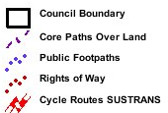
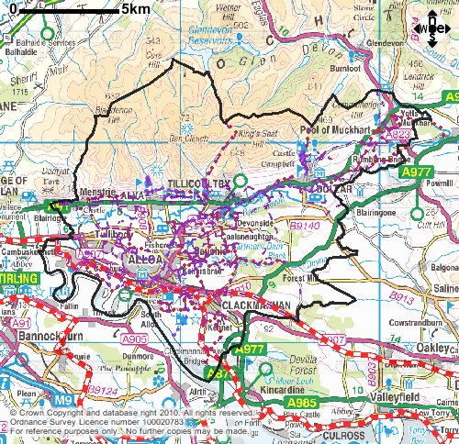
Figure E2: Walking and Cycling in Clackmannanshire (Core Path and Sustrans Networks)

The public transport system is focused in Alloa town centre with the main rail and bus stations located within a few minutes walk of each other. Bus services connect Alloa with Stirling, Falkirk, Fife and the main towns and villages of Clackmannanshire. The rail service provides a direct peak hours service between Alloa and Edinburgh, with a more frequent hourly service direct to Glasgow with connections to the rest of Scotland made at Stirling. A bus stance is also located in Tillicoultry serving the Hillfoots with connections to Alloa, Stirling and St Andrews. Whilst the bus network is reasonable, with frequent connections between Alloa and Stirling, services could be improved, especially in those areas with limited services in the off-peak or infrequent services throughout the day. There are some areas which are not served by any public transport. New public transport connections to the new hospital at Larbert are being sought in conjunction with NHS Forth Valley.

Clackmannanshire Council aim to:

- Reduce the impact transport has on the environment through the promotion of more sustainable modes of transport and reducing the need to travel.

Health

There is a clear link between transport and health. Transport has a major impact on health through accidents, air quality, physical activity and access to healthcare. The health amongst those considered to be at a social disadvantage is of great concern as these are the people most likely to be exposed to high levels of traffic leading to increased exposure to air pollution, noise, community severance and accidents.

Air pollution episodes are associated with rises in hospital admissions, increasing chronic asthma and premature death. Noise levels are also a disturbance to health through reduced concentration, stress and loss of sleep. Traffic is a significant source of air and noise pollution and a burden to the health service, especially when accident costs are also factored in.

Access to health care is particularly problematic for those with no or limited access to a car. In many instances people do not seek medical care or cancel appointments due to transport difficulties. Those with disabilities are at a distinct disadvantage due to physical and financial barriers. A new community healthcare centre opened in 2009 in Sauchie with access made possible by bus, cycling or walking. Access to the new hospital at Larbert is still under consideration but a direct bus service between Alloa and Larbert will be provided as a minimum.

Perceived danger from traffic leads to restrictions on independent mobility, especially amongst children. As a result more people use cars to access services where walking and cycling would be perfectly reasonable choices. Fear of road traffic accidents is one of the main driving factors behind the school run. With the increased dependency on the private car there is an ever increasing rise in obesity due to the reduction in physical activity.

Physical and mental well being can reduce the risk of many diseases and illnesses. Both walking and cycling are considered to fulfil the recommendations for exercise and can lead to a greater feeling of security and sense of community as people reclaim the streets from traffic. Promoting walking and cycling as a mode of transport can encourage people to get more active and reduce car use.

Clackmannanshire Council aim to:

- Work with Forth Valley NHS to meet the transport needs of patients, visitors and staff without the need for the car, through travel planning.
- Promote the benefits of walking and cycling as a form of transport and exercise.
- Direct road traffic from residential areas and reduce pollution wherever possible.

Climate Change

Air and sea temperatures are predicted to increase significantly in the 21st century – by as much as 2 to 3°C. East coast waters will warm at a greater rate than those in the west. We can anticipate wetter autumns and winters, drier, hotter summers and more unpredictable weather events. Changes in rain fall will affect run-off and erosion. These changes will have a knock-on effect on local biodiversity.

Climate Change is exacerbated by the emission of greenhouse gases. It has wide ranging implications for people, the economy and the natural and built environment in Scotland. Under the International Kyoto Protocol, industrialised countries will reduce their collective emissions of greenhouse gases by 5.2% averaged over the period 2008 - 2012 compared to the 1990 levels. The European Union agreement commits member states to an 8% reduction. Whilst no further climate change agreement was reached at the 2009 Climate Change Conference in Copenhagen, the Scottish Government has passed the Climate Change (Scotland) Act 2009. The act sets a target to reduce greenhouse gases in Scotland by 42% by 2020 and 80% by 2050. Transport will play a major role in meeting the targets.

Climate change will have direct and indirect impacts in Scotland. Over the next century, it is likely that Scotland will become warmer, sea levels will rise, rainfall and severe gales will increase and there will be an increased risk of flooding. There will be less snow lie during winter and marine and freshwater fisheries may be affected by changing ocean circulation.

Climate change impacts present an important business risk to the transport sector. Increased risk of flooding, storms and sea level rise will have serious detrimental impacts on land transport and marine operations. The provision of services across Scotland could also be affected. The changing climate will have an adverse effect on some business and domestic dwellings. The cold winter of 2009/10 has seen an increase in the use of salt on our roads and an increase in the number of potholes and other road defects arising as a result of the freezing and thawing.

In relation to public health, the secondary effects of climate change may result in increased air pollution and a higher incidence of respiratory diseases associated with damp conditions. However, positive impacts from warmer temperatures may include a reduction in cold-related deaths, and the feel-good factor associated with a warmer climate.

Climate change will have direct and indirect impacts: direct impacts through changes in the physical environment or in the cost of adapting to change and indirect impacts involving changes in society due to reductions in emissions of greenhouse gases. Over the next century, it is likely that:

- Scotland will become warmer. Average temperatures are likely to rise by between 1.2 to 2.6ºC, with relatively more warming in winter than summer.
- Annual precipitation is likely to increase by between 5 and 20 percent by the end of the next century, with autumn and winter seeing the biggest increases. In contrast, spring rainfall amounts will be lower and there will be little change in summer.
- The intensity of rainfall events is likely to increase, leading to increased risk of flooding.
- There may be an increase in the frequency of severe gales, and sea levels are expected to rise.

Extensive parts of Clackmannanshire are areas of flood plain. Flooding is a natural phenomenon that plays an important role in shaping the environment. However, climate change may mean that flooding becomes more severe and more frequent in certain areas. It should be managed rather than prevented and needs to be taken into account in decisions about locating development. In accordance with SPP7 - Planning and Flooding, the Council will take a precautionary approach to flooding by avoiding new development and infrastructure on land at risk from flooding. Only where the development cannot be sited in a less sensitive location will the risk of flooding be managed through the provision of mitigation measures.

The potential for flooding is greatest alongside the rivers Forth, Devon and Black Devon. In addition, the Forth estuary is an important strategic feature for reasons of ecology, landscape, recreation and flooding. This area is covered by the Forth Area Management Plan which identifies the impact of human activity on surface and groundwater. It also identifies water bodies at risk of failing to meet environmental objectives. The Council recognises the strategic importance of this area and will not support development which may adversely affect its overall integrity.

Sustainable Urban Drainage (SUDs) can aid flood control in an environmentally acceptable manner. In many instances SUDs offers the opportunity for ecological enhancement through new habitat creation.

Clackmannanshire Council aim to:

- Reduce greenhouse gas emissions from transport by reducing the need to travel and promoting more sustainable modes of transport.

Air Quality

Clackmannanshire Council has a responsibility under the Environment Act 1995 and Air Quality (Scotland) Amendments Regulations (2002) to improve air quality, not merely minimise pollution. The Air Quality Strategy for England, Scotland, Wales and Northern Ireland (2000) and the Addendum (2003) set health based objectives for nine air pollutants and two for the protection of vegetation and ecosystems. Where it is found that these objectives are unlikely to be met by the due date, then an Air Quality Management Area (AQMA) must be declared and an action plan setting out proposals for addressing the problems must be prepared. It is important for any air quality actions plans to be coordinated with the Local Transport Strategy and the planning system.

Many air quality hotspots in the UK are related to transport and vehicle emissions. Transport involves significant use of energy both from the fuel used by vehicles to the processing of materials for vehicle manufacturing and maintenance of the road surfaces. All of these activities can lead to decreased air quality and increased risk to human and environmental health. Tables 1 and 2 show the Air Quality Objectives and how these relate to transport. It should be borne in mind that Clackmannanshire Council only monitor air quality within urban areas.

In general pollutant concentrations within the Clackmannanshire area are low. This is due in part to the rural nature of much of the area. At present there are no Air Quality Management Area's within the Council area.

Nitrogen Dioxide

Clackmannanshire Council operates a network of ten Nitrogen Dioxide (NO₂) diffusion tubes for the purposes of monitoring the volume of NO₂ in the air. There has been a gradual increase in NO₂ concentrations, following several years of decline through to be due to new car technologies such as more efficient vehicles and cleaner fuels. NO₂ levels are now static or gradually increasing as the increased volume of cars on the roads overrides the technological advances. However the annual mean NAQS objective for NO₂ was not exceeded in 2008 and are still significantly below legal standards.

Sulphur Dioxide

In 1954 an 8-port bubbler was installed at Alloa Town Hall to monitor Sulphur Dioxide (SO₂) concentrations in the air. The equipment recorded SO₂ levels in Alloa for over 50 year and the data collected indicated that the levels of SO₂ in Alloa are significantly below the NAQS objectives. Therefore with the very low results, SO₂ levels have been beyond the detection range of the equipment and as a result the equipment has been removed. However SO₂ emissions are still subject to an annual review and if an issue arises then new technology may be hired in.

Particulate Matter

The concentration of particulate matter in the air (PM₁₀) is monitored by Clackmannanshire Council at a road side site on King Street to the north of Alloa town centre.

Monitoring of PM₁₀ levels in between 2007 and 2009 indicated that they were borderline in terms of the legal standards. No extraneous reasons have been identified and if these levels continue further investigation will be undertaken. It is unlikely this will lead to the declaration of an AQMA. Recent research has identified that smaller particulates (PM_{2.5}) may be more damaging than PM₁₀ and in the fullness of time monitoring of these smaller particles may be undertaken.

It should also be noted that there are other significant pollutants in the area, for which there is no current monitoring regime. These pollutants include carbon monoxide, benzene, lead and 1, 3-butadiene. However, it is considered very unlikely that any of these pollutants exceed the NAQS objectives, they are currently estimated in the order of 5 - 10% of the legal requirements.

Clackmannanshire Council aim to:

- Improve air quality by reducing the impact of transport through the promotion of more sustainable travel, minimising long term congestion at sensitive locations and promoting improved technology in vehicles and fuel
- Reduce the number of vehicles taking children to school, as this increases air pollution at the very time that children are most likely to be at the side of the road and exposed to pollution.

Pollutant | Objective |  | Date to be achieved by | Contribution by Transport | Transport Mitigation
Pollutant | Concentration | Measured as | Date to be achieved by | Contribution by Transport | Transport Mitigation
Benzene | 3.25μg/m³ (1ppb) | running average mean | 31/12/10 | Combustion and distribution of petrol. Diesel is a relatively small source of benzene. | Projections indicate transport emissions decrease of 79% between 1995 & 2010 as a result of lower maximum benzene levels in petrol.
1,3 - Butadiene | 2.25μg/m³ (1ppb) | running average mean | 31/12/03 | Derived mainly from the combustion of petrol, motor vehicles dominant source. Also from production of synthetic rubber for tyres. | New emission limits and new fuel standards. Reduction in car use
Carbon Monoxide | 10mg/m³ (8.6 ppm) | running 8 hour mean | 31/12/03 | Road transport accounts for about 69% of UK CO emissions, mainly from petrol engines. | New emission limits and new fuel standards. Reduction in car use.  Forecast decrease of 40% between 1995 & 2005
Lead | 0.5μg/m³  0.25μg/m³ | annual mean  annual mean | 31/12/04  31/12/08 | Most airbourne emission of lead have arisen from lead based fuels used in vehicles | Lead fuel banned from 1 January 2000
Nitrogen Dioxide | 200μg/m³ not to be exceeded more than 18 times a year  40μg/m³ (21ppb) | 1 hour mean  annual mean | 31/12/05  31/12/05 | Road transport largest source of NO_{x} in UK – 50%. Arises as a result of combustion processes. NO_{x} is precursor to ozone | New emission limits and new fuel standards. Reduction in car use
Particles (PM₁₀) | 50μg/m³ not to be exceeded more than 7 times a year  18μg/m³ | 24 hour mean  annual mean | 31/12/10  31/12/10 | In 1999 road transport accounted for 17% of PM₁₀ (76% diesel/24% petrol). | New emission limits and new fuel standards. Fitting of particulate filters on older vehicles. Reduction in car use.
Sulphur Dioxide | 350μg/m³ (132 ppb) not to be exceeded more than 24 times a year  125μg/m³ (47ppb) not to be exceeded more than 3 times a year  266μg/m³ (100ppb) not to be exceeded more than 35 times a year | 1 hour mean  24 hour mean  15 minute mean | 31/12/04  31/12/04  31/12/05 | Negligible – mainly arises as a result of combustion of fossil fuels (coal and heavy oil) | Most diesel fuel now sulphur free.
Polycyclic Aromatic Hydrocarbons (PAHs)  Benzo[a]pyrene (B[a]P) | 0.25ng/m³ B[a]P | as annual average | 31/12/10 | 8% from road transport. B[a]P is predominantly present in air attached to particles. Vehicles no longer considered significant source of B[a]P. | Reduction in PM₁₀ from vehicle emissions will reduce future emission of PAHs.
Table E.1: Air Quality Objective (Scotland) for LAQM

Pollutant | Objective |  | Date to be achieved by | Contribution by Transport | Transport Mitigation
Not Included in LAQM (national objective)
Ozone | 100μg/m³ (50ppb) not to be exceeded more than 10 times a year | daily maximum of running 8 hour mean | 31/12/05 | Oxides of nitrogen and Volatile Organics Compounds (VOCs) react to form ozone. NO_{x} from vehicle emissions source of ozone from transport sector. | Reduction in NO_{x}, from reduced car use, new emission limits and fuel quality standards.

Objective for the protection of vegetation and human health
Nitrogen Oxides | 30μg/m³ (15ppb) | annual mean | 31/12/00 | As above | As above
Sulphur Dioxide | 20μg/m³ (8ppb)  20μg/m³ (8ppb) | annual mean winter average (1 October to 31 March) | 31/12/00  31/12/00 | As above | As above
Table E.2: Air Quality Objective (National)

Noise and Vibration

Exposure to prolonged noise and vibration can have a detrimental impact on the quality of life. Transport and road construction/maintenance is a major source of noise and vibration. The nuisance level resulting from noise and vibration can vary greatly amongst individuals and their reaction to the exposure.

A residents panel survey undertaken by the Royal Borough of Kensington and Chelsea indicated that noise from road traffic was the most annoying source of noise pollution, followed by construction, demolition, renovation or road works.

Local Authorities in Scotland have a statutory duty under the Road Traffic Regulation Act 1984 to consider the impact of road construction and similar works and must exercise its powers in connection with the control of traffic. The Local Authority is also responsible for carrying out noise impact assessments and mitigation measures for new and improved roads as laid out in the Noise Insulation Regulations 1975 (as amended).

The prevention of noise as a result of transport requires an avoidance or restriction of potential noise impacts before they occur. Through the careful integration of land use planning with transport provision it is possible to prevent potential adverse noise impacts in new developments and transport schemes.

EU Environmental Directive 2002/49/EC states that by July 2007 all major roads with more that 6 million vehicle passages per year require to be mapped for ambient noise levels, with action plans put in place to mitigate any identified noise issues. In Clackmannanshire two roads have been identified as likely to require noise mapping, as shown in Table E.3 below.

Road | 2009 Flow | Mapping Required
A907 Blackgrange |  | Yes
A907 Cambus |  | No
A907 King Street |  | Yes
A907 Clackmannan |  | No
A91 Menstrie |  | No
A91 Menstrie-Alva |  | No
A91 Alva-Tillicoultry |  | No
A91 Muckhart |  | No
A908 Blackfaulds |  | No
A908 Fishcross |  | No
B9140 Tullibody Bypass |  | No
B9140 Muirside |  | No
B9096 Tullibody |  | No
B9096 Alloa |  | No
A977 Gartlove |  | No
B908 Fairfield |  | No
Table E.3: Yearly Traffic Flows on Strategic Roads

On average the Council receives ten complaints annually from the general public regarding noise disturbance from transport. These are commonly attributed to noisy vehicles which would be reported to the police or noise complaints associated with roads defects such as pot holes. However with the opening of the railway thee has been an increase in the number of complaints relating to the noise and vibration associated with the freight services operating through Clackmannanshire.

Clackmannanshire Council aim to:

- Minimise the noise and vibration associated with transport, especially in sensitive areas, by encouraging less dependency on the car, promoting freight transport to travel on strategic freight routes and implementing HGV restrictions where appropriate

Water Status

The EU Water Framework Directive introduced a new approach to the classification of water bodies throughout Europe into the following categories - High, Good, Moderate ,Poor or Bad Status. The status is based on a number of characteristics of the water bodies - chemical, ecological, flow and morphology with status being determined by the lowest classification factor.

The Upper Forth Estuary is classified as poor due to invertebrate population and hydro morphology pressures respectively. Issues such as diffuse pollution and regulated flows result in the majority of Clackmannanshire's water bodies being classified as moderate or poor with presently only Menstrie and Dollar Burns achieving a good status The Water Framework Directive's ambition is to improve the status of Europe's water bodies on a six year cycle basis. The Forth Area River Basin Management Plan covers Clackmannanshire and includes measures to improve the status of our rivers and streams .

Clackmannanshire Council aim to:

- Minimise the impact of transport on the area’s water resources by introducing SUDs (Sustainable Urban Drainage Systems) in new transport schemes where appropriate.

Flooding & Sea Level Rise

Flooding is a natural phenomena that has played an important role in shaping the environment of Clackmannanshire, and will continue to be part of the natural cycle of events which serve to sustain the area’s river ecosystems. The low lying floodplains of the Rivers Devon and Black Devon are two key areas where the risk of inundation is important. Areas adjacent to the Forth Estuary may be at risk from tidal flooding, caused by a combination of sea level rise, high tides, high rainfall and breaks in flood banks. Flooding can also occur in the upland areas as burns overtop their banks, due to heavy rainfall. Flooding can potentially be caused by transport schemes where changes to run-off or drainage patterns occur.

Improved mapping of potential flood prone areas is presently under development and should soon be made public on a national scale. Under the present mapping system coastal flood risk is assumed for any properties or infrastructure less than five metres above the high tide level. The A91 at Dollar, the B908, Marchglen and Shavelhaugh Loan have been affected by flooding during instances of high rainfall. A significant flood event occurred in January 2008 when the River Devon overtopped the old railway embankment at Elistoun Drive inundating a number of properties in Tillicoultry.

The Council is designated as being responsible for the promotion of sustainable flood management and to participate in river basin management planning under the Water Environment and Water Services (Scotland) Act 2003.

The Flood Risk Management (Scotland) Act 2009 sets out new duties on certain public bodies, including local authorities, to clarify responsibilities for flood risk assessment and flood management planning in Scotland. It gives local authorities powers, and streamlines the approval process, to take forward a range of sustainable flood management measures. It also provides for the efficient use of local resources to introduce timely flood management measures and amends the Reservoirs Act to replace the enforcement regime operated by local authorities, placing a new enforcement duty on SEPA.

Clackmannanshire Council aim to:

- Minimise disruption on the transport network from flooding as a result of climate change, by ensuring new schemes are not at risk and by careful design which does not adversely impact on existing drainage patterns.

Geology and Contaminated Land

Scotland has a rich and diverse geology, with Clackmannanshire vividly shaped by Scotland’s glacial past. The Ochils are the oldest strata within Clackmannanshire and consist of volcanic rocks. There is considerable distinction between the Ochils and the rest of the area, as the Ochils consist mainly of bedrock with small areas of peat and some glacial channels, particularly on the northern side.

The Kincardine basin in which the rest of Clackmannanshire lies, exhibits evidence of coastal and marine sedimentation and erosion. This lower strata consists of coarse sandstones, mudstones and siltstones and is highly fertile land. The western area contains a band of post glacial beach deposits and alluvium along the border of the Ochils, encompassing Alva. This band is intersected by a band of boulder clay, which covers Sauchie and Tullibody. There are also areas of river terrace alluvium, sands and gravel around Dollar and Tillicoultry.

There has been considerable deposition of coal in the area, which dominate the Sauchie and Coalsnaughton areas and have been extensively mined throughout history. There are issues relating to potential subsidence due to shallow mine workings throughout Clackmannanshire.

Historical sources of contamination have been associated with industrial development, particularly mining, and agricultural practices. Areas most susceptible to groundwater pollution and contamination are generally those that are more permeable. The areas of Clackmannanshire that are most susceptible are the areas of alluvial and sand/gravel deposits in the Dollar area. The Contaminated Land (Scotland) Regulations 2000 was introduced to deal with the legacy of contaminated land as a result of industrial development in the past couple centuries in Scotland. In response to these new regulations Clackmannanshire Council has implemented a Contaminated Land Strategy.

It is considered that transport plays an insignificant role in geology and contaminated land. However climate change may lead to infrastructure subsidence, depending on the underlying ground conditions. Transport does contribute to contaminated land from surface run-off of salt and other transport related pollutants such as tyre wear, oil and fuel spillages and transport accident spillages. This is not considered to be a serious problem in Clackmannanshire.

Clackmannanshire Council aim to:

Identify those parts of the transport infrastructure on land likely to lead to subsidence i.e. peat or shallow mine workings and monitor for change.

Waste Management

Significant progress has been made in recent years with regard to waste management in Clackmannanshire. The National Waste Strategy and the European Council Landfill Directive established a framework for reforming the waste management system in Scotland and sets targets for improving the sustainability of waste management up until the year 2020. Clackmannanshire is currently ahead of the national targets and continuing to improve rapidly. During the period 2006 - 2009 The Council's Road Contracts recycled 2718 tonnes of tar cuttings during road construction projects.

In 2010 Scotland's Zero Waste Plan will provide new direction and guidance on making Scotland a zero waste society with new targets to reduce landfill to 5% and increase recycling and composting to 75% by 2025.

Clackmannanshire Council aim to:

- Promote the use of recycling in construction and maintenance of transport infrastructure, through the reuse of uplifted materials and so limiting landfill.

Biodiversity

Biodiversity can be defined as the total variety of living organisms on earth, including all species of plants and animals and their associated habitats. Scottish Natural Heritage has defined 21 distinct natural heritage areas in Scotland, these areas have their own identity resulting from an interaction of geology, landforms, landscapes, wildlife and land use, and thus are affected by distinct issues. Clackmannanshire is classified as lying within the Eastern Lowlands of Scotland.

The Eastern Lowlands are characterised by low coastline and extensive floodplains, a key reason why climate change is such an important consideration for the area. The area is of particular importance for its coast and estuaries, river systems, agriculture and settlements. The low coastline is backed by broad, flat farmed carseland, leading up to the sharply defined steep sides of the major geographical fault lines in the north and west of the Eastern Lowlands. This carseland and fault line is extremely prominent in Clackmannanshire, where the Ochil Hills providing stunning definition of the carseland meeting the fault line.

The Clackmannanshire area contains various types of native grassland ecosystems and some areas of bracken dominated land cover. The area supports various forms of woodland, including mixed forest and coniferous plantations. A large percentage of Clackmannanshire is fertile arable land on the low lying carseland. The area also contains salt marshes and other estuarine ecosystems. These diverse environments, including the urban areas, all support a complex system of species and interacting processes. It is not only natural environments that must be managed appropriately to maintain biodiversity and progress toward the goal of sustainability, other environments such as agricultural and urban, are also vitally important.

Transport infrastructure and corridors can provide ideal habitats for many species of plant and animal. However without consideration of biodiversity and careful management and mitigation when planning for transport, habitats can become fragmented and there can be adverse impacts on flora and fauna through the use of chemicals, increased incidents of pollution and changes to the drainage and hydrology of the areas adjacent to the corridor. Transport is also hazardous for animals crossing roads and may cause a disturbance to certain species leading to a decline in biodiversity.

Transport corridors provide habitats for many different species. Verges, cuttings and embankments can contain a great diversity of wild flowers, so are very important feeding areas for all sorts of species e.g. insects, kestrel, voles. The timing of maintenance works such as grass cutting do however need to be carefully managed to maximise the biodiversity potential of a route.

Bridges can provide homes for bats and birds, especially older structures. However bridges can also create a barrier to other species such as otters and foxes, and they therefore require further assistance to negotiate the bridge using features such as ledges to avoid interacting with road traffic. Many transport corridors include drainage systems that can be attractive to wildlife, however these need to be designed in such a manner to prevent small animals from becoming trapped in features such as gully pots.

Species | Location | Comments Relevant to Transportation and Roads
Water vole | Distribution to be determined (surveys 06/07). Historically very widespread across Clackmannanshire’s watercourses | Avoid removal of natural bankside vegetation and features.
Brown hare | Distributed across rural Clackmannanshire. | Field margins and verges are key habitats for brown hare. Avoid the loss/deterioration of roadside hedges and grass verges.
European otter  European Protected Species | Over the past decade otter numbers have increased significantly. Now occur on most watercourses & riparian areas in Clackmannanshire. | Otters require access to clean watercourses, a sustainable food source and adequate cover on banksides – avoid removing riparian vegetation and natural features, avoid closed river crossings - e.g. culverts, aim to provide access ledges in new bridges. Applies to all river works. Operations likely to result in disturbance, contact SNH/SEERAD over licence requirements.
Bats  European protected Species¹ | Soprano pipistrelle widespread and numerous across Clackmannanshire. | Operations likely to result in disturbance, contact SNH/SEERAD over licence requirements. Roost sites are frequently found in old bridges and woodland strips along roadsides
Skylark, tree sparrow, bullfinch, linnet, yellow hammer | Populations in decline and localised. Occur within lowland farmland area of Clackmannanshire. | Field margins and hedges are key habitats for bird species. Avoid the loss/deterioration of roadside hedges and grass verges.
Grey partridge | Status unknown. Populations are thought to be low occurring on arable land throughout the lowland area to the south of the Hillfoots Road. | Field margins and hedges are key habitats for grey partridge. Avoid the loss/deterioration of roadside hedges and grass verges.
Red Squirrel | Locally rare species, found in the east of Clackmannanshire (recorded in Dollar, Forestmill, Muckhart areas) | Highly susceptible to disturbance including construction, habitat fragmentation and road kills. May require specific mitigation measures e.g. rope road crossings.
Badgers  (Protection of Badgers Act 1992) | One known sett in north west of Clackmannanshire | Badgers have large territories, highly susceptible to disturbance of their setts and road kills. May require specific mitigation e.g. badger tunnels
Table E.4: UK Priority Species Recorded in Clackmannanshire in the Last Ten Years

Safety will always be the primary concern of Clackmannanshire Council when working on the transport network. There is however the potential for an integrated approach to be adopted that maintains a safe and efficient road network that also enhances the biodiversity of the area.

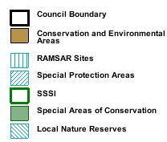
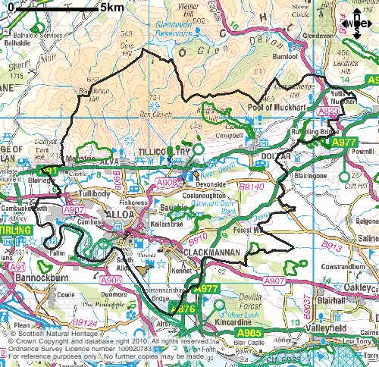
Figure E.3: Designated Biodiversity Areas in Clackmannanshire

Clackmannanshire contains nine Sites of Special Scientific Interest (SSSI), these are designated areas for natural heritage, including wildlife habitats, geological features and landforms. 249 hectares of Clackmannanshire are within a Special Protection Area (SPA) and RAMSAR Site on the Forth Estuary. SPAs are primarily for the protection of rare, vulnerable and migratory birds, and RAMSAR Sites are an international designation for the protection of wetlands. The area was recently designated primarily for the protection of migratory bird species visiting the Forth Estuary. Within the Council area is Gartmorn Dam, the site of the Country Park and Local Nature Reserve, which overlap. These are places for both people and wildlife with wildlife or geological features of special interest locally. See Table E.4 for the respective area of each different type of designated site and Figure E.3 for their locations.

Type of Protection Designation | Area (ha) | % of Council Area
Country Park (CP) | 68 | 0.4
Local Nature Reserve (LNR) | 44 | 0.3
Sites of Special Scientific Interest (SSSI) | 801 | 5
Special Protection Area (SPA) | 249 | 1.5
RAMSAR Sites | 249 | 1.5
Table E.5: Designated Protection Source: SNH Facts & Figures

Through the Clackmannanshire Biodiversity Action Plan 2003 - 2008 the Council has established action plans for priority species and habitats within the Clackmannanshire Council area. There are action plans in place for several invertebrate species, Atlantic salmon and brown trout, the common lizard, and several bird and mammal species including the badger, red squirrel and the peregrine falcon. There are also action plans in place for farmland and grassland, upland, urban and industrial land, water and wetland, and woodland. Several important habitats have increased in area in recent years, including some forms of woodland that are vital habitats for many species.

Figure 3.4: Land Cover in Clackmannanshire
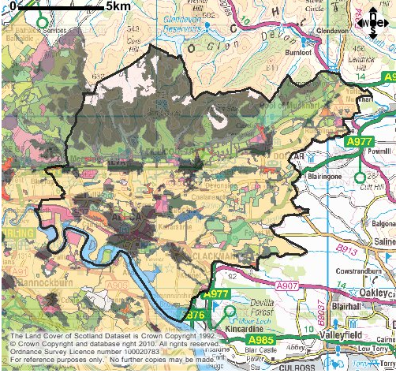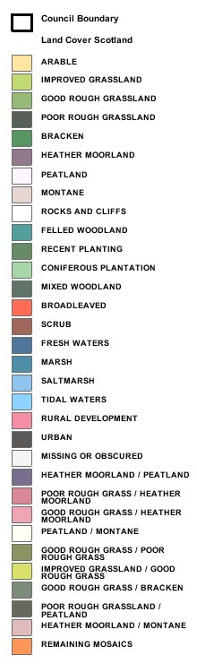
Figure E.4: Land Cover in Clackmannanshire

Clackmannanshire Council aim to:

- Conserve and enhance biodiversity within Clackmannanshire, through the development of road verges as potential meadow resources and planting native species in new transport schemes and maintenance works where appropriate

- Ensure that all designated biodiversity sites are protected and reduce habitat fragmentation through design and positive management of the transport network

- Mitigate against the adverse impacts of transport and drainage on local species by identifying sensitive habitats in order to avoid or prevent adverse impacts through careful control and design

- Protect designated species i.e. badgers, otters and red squirrels where possible through avoidance or the introduction of mitigation measures in new transport and maintenance schemes which are likely to create an adverse impact

Rural Land Use

Agriculture and Soil

Soil is a key component of the terrestrial biosphere. It provides a living medium that supports the growth of both agricultural plants and native flora, which provides a habitat for a wide diversity of fauna. Soils are sensitive to the impacts of chemical pollution from air or water and to physical degradation through cultivation, water and wind erosion.

Agriculture is the most extensive land use within the area and occurs on varied topography and soils. There are some areas of cereal farming, but grazing of livestock is the predominant agricultural use in the area. The majority of agriculture is on the highly fertile flat carseland areas. Most agriculture in the area is relatively non-intensive.

National policy recommends protection of prime agricultural land, as sustainable agricultural activities are a fundamental component of achieving overall sustainability. Clackmannanshire is blessed with very fertile soils, with several areas classed as prime agricultural land, particularly in the carseland areas, Figure E.5. However, unsustainable farming can result in major decline in soil quality. For soil to be considered a sustainable resource, the adverse impacts of erosion and structural decline of soil must be managed and reduced. The drainage from roads can have an impact on soil quality in the surrounding area, however the magnitude of this impact on the environment is not known.

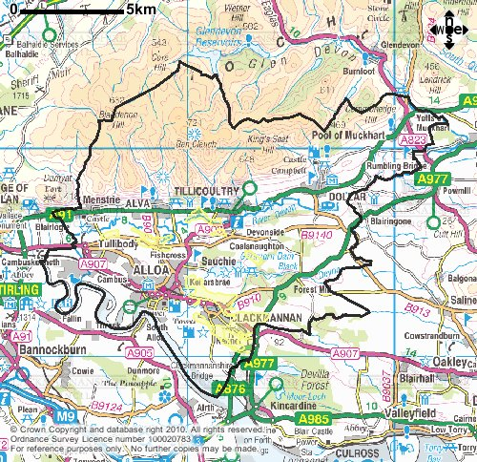
Figure E.5: Prime Agricultural Land in Clackmannanshire

Clackmannanshire Council aim to:

- Protect and improve soil quality and prevent soil erosion when designing new transport schemes, through the careful design of planting and drainage schemes

Forestry

A significant area of eastern Clackmannanshire is covered by forest. Planting of new woodlands and the management of existing woodlands have many important implications for rural employment and the local economy, biodiversity, landscape quality and recreational opportunities. In addition to significant amounts of commercial plantation woodland, the area contains important semi natural woodlands. Of great importance, particularly in terms of natural heritage and biodiversity are Clackmannanshire’s ‘ancient and semi natural woodland’. ‘Ancient and semi natural woodland’ is generally defined as forest or woodland that is typically older than 200 years with large trees, dense canopies and an abundance of diverse wildlife, Figure E.6.

The Clackmannanshire Biodiversity Action Plan outlines detailed actions for the conservation of woodland species and habitats. Forestry and woodland expansion and restructuring will in most cases offer opportunities to work towards meeting the expressed biodiversity objectives for the area. It is important to recognise the strong connection between forestry and other environmental issues. Forestry can have a positive influence on air, soil and water quality, biodiversity, the local economy, landscape value and the anxiety levels and sense of place within the local community.

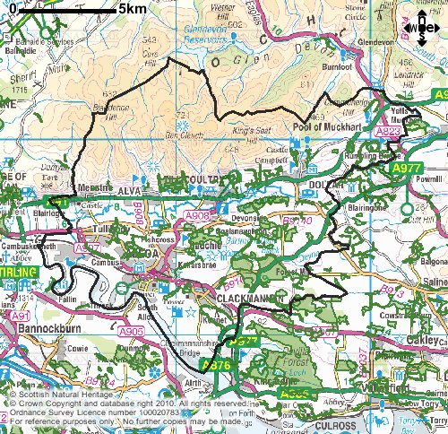

Figure E.6: Ancient Woodland in Clackmannanshire

Clackmannanshire Council aim to:

- Ensure new and realigned roads are designed to minimise the impact on ‘ancient’ woodland wherever possible.

Open Space

Since the Victorian traditions of philanthropy and patronage to the local community of public open space, public administrations have gained control of significant areas of land in Clackmannanshire for public benefit. Topography and settlement development have shaped the type of open space now present. There are large public parks with frontages to the A91 along the Hillfoots, stemming from traditions of access to the Ochils by local communities and visitors alike. Dollar being the exception in this area, which is more reliant on privately owned space.

Clackmannan’s open space is spread throughout the settlement, with the public park and later cemetery being separated from the historic heart of the village, with the church standing alongside the hilltop of Clackmannan Tower.

Alloa, Sauchie and Tullibody are now almost one continuous urban area. Nevertheless, there are significant pockets of public open space, including historic graveyards and later cemeteries. Public benefaction and the Victorian enlightenment in the form of public parks and spaces around the former mansion houses linked with the Patons family also make up a large percentage of the areas open space. Alloa has a relatively large number of significant areas used as parks compared with other urban areas.

Open space is also now linked closely with the growing pedestrian and cycle network, whilst there are smaller areas linked to historic sites and memorials. Open space linked to water is primarily at Gartmore Dam, with very little access to open space associated with the River Forth within Clackmannanshire.

The promotion of good quality public space and streetscape through proper design and maintenance of roads, traffic management schemes and the promotion of walking, cycling and public transport is essential within Clackmannanshire. The careful use of street furniture, vegetation and lighting it is possible to achieve a high quality local landscape and enhance biodiversity.

Clackmannanshire Council aim to:

- Take opportunities to maintain or create open space within new developments

Greenbelts

The use of clear settlement boundaries and Green Belt boundaries maintains distinction between built-up areas and the countryside. It is appropriate to exercise strict control to prevent sprawl into the countryside and the joining up of settlements. In Green Belt areas development is only permitted in exceptional circumstances and any developments which are permitted are expected to demonstrate appropriate environmental enhancement within the Green Belt. Green Belts are extremely important both in terms of planning for future development requirements as well as providing for conservation and maintenance of biodiversity. Clackmannanshire has an important network of greenbelts, particularly along the Hillfoots, between Alloa and Tullibody, and between Alloa and Clackmannan, Figure E.7.

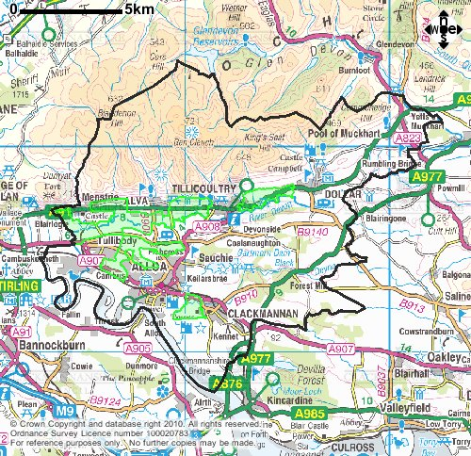

Figure E.7: Greenbelt Areas in Clackmannanshire

Scenic and Landscape Values

The dominant and spectacular backdrop to Clackmannanshire is the Ochil Hills. The Ochils represent approximately one third of Clackmannanshire, which contains their highest point, Ben Cleuch, at 721m in height. This scenic backdrop to Clackmannanshire is seen from many places and constantly catches the light differently adding to its beauty. There are two areas within Clackmannanshire that have been designated Areas of Great Landscape Value (AGLV) to establish a framework to maintain and enhance urban and rural scenic and landscape qualities, Figure E.8. The Ochils are the main AGLV and a smaller area east of Alloa and north of Clackmannan is also designated for its prominence, being a slightly higher area than its surrounding and including Clackmannan Tower. High volumes of transport in areas of scenic value can have an adverse impact on the environment and can impact on tourism and therefore the economy.

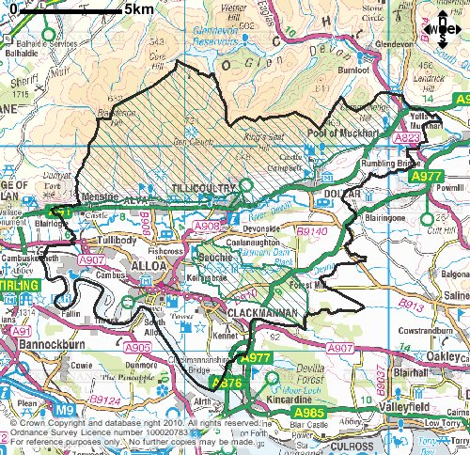
Figure E.8: Areas of Great Landscape Value within Clackmannanshire

Clackmannanshire Council aim to:

- Protect and enhance landscape character, whilst retaining opportunities for enjoyment of the countryside and townscape, through the promotion of walking and cycling to reduce car dependency and reduce the need for new transport infrastructure including car parks

Built Heritage

Clackmannanshire has a rich cultural history and signs of this are never far away wherever you are within the ‘Wee County’. There are a number of reasons why it is important to conserve cultural and historic assets, which vary widely depending on personal ontology. These reasons include cultural identity, aesthetic values of the area, as resources for both the sciences and the arts and as time capsules of the past.

Listed Buildings are those buildings that have been given legal protection due to their architectural or historic interest and which help to provide a rich cultural history of the area. Clackmannanshire contains 307 listed buildings – 17 Category A, 156 Category B and 134 Category C(S) as at 9th February 2010. Figure E10 shows the scheduled ancient monument and conservation areas within Clackmannanshire.

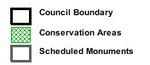
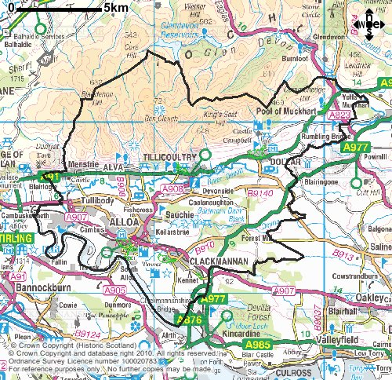

Figure E.9: Scheduled Ancient Monuments and Conservation Areas in Clackmannanshire

Monuments can form a wide range of physical markers to an era or point along the passage of time, generally providing a window into the human history of the area. Scheduled Ancient Monuments are monuments that have legal protection within Scotland. There are 17 Scheduled Ancient Monuments within Clackmannanshire, which include a tombstone, two bridges, a cairn, Castle Campbell and Mannan Stone, amongst others. There are thirteen listed bridges in Clackmannanshire, eight of which are public roads the remaining five are only open to pedestrians and cyclists, Table E.6.

Name | Classification
Tullibody Old Bridge | Scheduled Monument, A Listed
Cambus Iron Bridge | Scheduled Monument, A Listed
Ochil Road Bridge, Menstrie | B Listed
Keverkea Bridge, over Balquharn Burn | C (S) Listed
Balquharn Bridge, Alva | C (S) Listed
Bridge over Black Devon, Clackmannan | C (S) Listed
Linn Mill Bridge, Clackmannan | C (S) Listed
Middle Bridge, over Dollar Burn | B Listed
North Bridge, over Dollar Burn | C (S) Listed
Kellybridge, Dollar | C (S) Listed
Muckhart Mill Bridge, over Hole Burn | C (S) Listed
North Fossoway Bridge, over River Devon | C (S) Listed
Shillinghill Bridge, over Tillicoultry Burn at Clock Mill | B Listed
Table E.6: Listed Bridges in Clackmannanshire

National Monuments, which can also be buildings or archaeological sites, do not necessarily have any legal protection. However, they may be protected under Listed Buildings or Scheduled Ancient Monuments legislation. There are several hundred National Monuments within Clackmannanshire.

Historic sites have a great influence on the tourist traffic through Clackmannanshire, leading to a positive impact on the economy. However too much vehicular traffic can create environmental problems both within Clackmannanshire and in the vicinity of the tourist attraction. Vehicles do not make for an attractive visual sight, vibrations from large vehicles can impact on historic buildings and pollution can erode or stain the features of historic buildings. Through reducing dependency on the car for travel to and past historic sites, the integrity of Clackmannanshire can be retained.

Clackmannanshire Council aim to:

- Protect, enhance and make accessible the designated and wider historical environment and assets of the area, through the careful design and maintenance of transport infrastructure to be sympathetic to the local characteristics where this is appropriate

- Retain existing infrastructure, such as bridges, in a usable condition where possible

Key Issues and Opportunities

- Future sea-level rise:

Potential increase in intertidal areas, implementation of realignment and mitigation policies.

Transport is responsible for a proportion of emissions which are contributing to climate change and therefore sea-level rises. Through cleaner vehicle and fuel technology and better use of the private car, transportation can reduce its impact on the environment.

- Integrated catchment management:

Development of measures to alleviate potential for, and impacts of flooding,
implementation of more sustainable management.

New transport schemes can integrate SUDs, to alleviate the impact of run-off associated with transport.

- Agricultural intensification:

Potential for loss of biodiversity and diminished quality of landscapes, water and habitats, opportunities for restructuring of agricultural practices to enhance the environment.

Transport can contribute to increasing biodiversity adjacent to agricultural land by providing meadow type verges in new schemes and works and through replacing gaps in hedgerows.

- Built development in urban and countryside areas:

Opportunities for more sustainable techniques and materials to be used in development.

Transport can contribute to a more attractive urban and rural area through proper design and careful consideration of construction and maintenance techniques.

- Sense of place:

Opportunities to improve community identity and sense of place through maintaining and enhancing Clackmannanshire’s various landscapes and environments.

Through the provision of high quality walking and cycling networks, society can become less dependant on the car leading to improved community spirit and busy lively neighbourhoods.

- Biodiversity:

Potential for loss of biodiversity through agriculture, development, pollution, the effects of climate change and poor environmental management; opportunities for protection and enhancement of biodiversity through integrated and proactive management, including the Clackmannanshire Biodiversity Action Plan.

Transport can contribute to biodiversity through the careful consideration of new scheme design and maintenance of existing infrastructure. Practices to maximise biodiversity and minimise the impact on the local environment will enhance Clackmannanshire as a whole.

- Infrastructure and services:

Potential for waste and transport management to render Clackmannanshire highly unsustainable;

Opportunity to effect similar sustainability reforms to the transport system as are occurring in waste management.

- Renewable Energy Sources:

There is great potential for the expansion of renewable energy supplies in the area and improved energy efficiency.

At a national level there is potential for more renewable forms of energy to be used to fuel all vehicles, which would contribute to cleaner air.

- Climate change:

Minimising climate change and preparing for the impacts of already inevitable climate change is a key issue for a sustainable future in Clackmannanshire.

Reducing the need to travel and by encouraging other more sustainable forms of transport will reduce the impact on the environment.

- General:

Opportunity to consider the potential impacts on the state of the Clackmannanshire environment of activities, proposals, plans and policies.

The Local Transport Strategy sets out how the Council are proposing to encourage more sustainable practices towards the environment, whilst not having a detrimental impact on the economy, safety, social inclusion or accessibility.

European Protected Species – protected against killing and injuring, taking. Damage to, destruction of, obstruction of access to any place used by a scheduled species for shelter of protection (e.g. otter holts)

